KERALA INDUSTRIAL INFRASTRUCTURE DEVELOPMENT CORPORATION (KINFRA)

REQUEST FOR PROPOSAL TO OPERATE, RUN AND MAINTAIN COLD STORAGE/ PRIMARY PROCESSING CENTRE (CS/ PPC) IN KINFRA SMALL INDUSTRIAL PARKS AT MAZHUVANNOOR AND KALPETTA

1. INVITATION FOR BIDDING
1.1 Kerala Industrial Infrastructure Development Corporation (KINFRA), a Statutory Body established by Govt. of Kerala has been the leader in providing industrial infrastructure for the State of Kerala. It has established a chain of Industrial Parks across the length and breadth of the State which include industry specific theme-based parks/special economic zones. For the Food Processing Industry, five Food Parks namely, KINFRA Food Processing Park (KIFPRO) at Kakkancherry, Special Economic Zone (Agro Food Processing) at Kakkancherry, Food Zone at KINFRA Small Industries Park (KSIP) at Mazhuvanoor, KINFRA Food Park at Adoor, and Sea Food Park at Aroor have been established.
1.2 The objective of setting up food parks is to facilitate investors/ entrepreneurs to set up food processing units with ease in industrial parks designed to suit their needs. Several common facilities are provided in Food Parks in the form of Common Facility Centers, for e.g. Cold Storages. The purpose of Cold Storages is to enable stakeholders of the Food Processing sector to reduce wastage of perishable produce and increase shelf life of food products.
1.3 KINFRA wishes to select an Operating Agency through a transparent, competitive bidding process and invites Business Plan & Price Bid from interested parties in accordance with this “Request For Proposal (RFP)" to operate, run and maintain the cold storages in KINFRA Small Industrial Parks at Mazhuvannoor and Kalpetta (hereinafter referred to as “Cold Storages”). This RFP has been prepared to assist prospective Bidders in taking suitable decision regarding the bid.
These cold storages will be given to the operator in “as is where is condition”. All aspects of work related to the overhauling, maintenance and replacement of equipment parts shall be carried out by the Operating Agency at his cost. The rectification works of existing electrical, fire fighting systems and all supporting systems also shall be executed by the operating agency.
1.4 KINFRA invites offers from Bidders for operating, running and maintaining the Cold Storage/Primary Processing Center as per the conditions stipulated in the RFP document.
1.5 In this RFP, the term "Bidder" refers to the interested party for operating, running and maintaining the Cold Storages in KINFRA Small Industrial Parks at Mazhuvannoor and Kalpetta, and who submits Business /Development Plan& Price Bid for the Cold Storages operation as per this RFP. Bidders should provide information sought herein the prescribed formats in order to accurately establish their qualification for operation of the Cold Storages in KINFRA.
1.6 Correspondence in response to this RFP as well as related queries must be addressed to The Managing Director, KINFRA House, TC 31/2312, Sasthamangalam, Thiruvananthapuram- 695010

2. PROJECT PROFILE

  - KINFRA has constructed cold storages in KINFRA parks as per details below:-
- KINFRA Small Industries Park, Mazhuvannoor in Ernakulam District: The Cold Storage is located inside a separate plot in an independent building within the park premises. Facilities for pre-processing activities have also been provided.
- KINFRA Small Industries Park, Kalpetta in Wayanad district: The cold storage is located inside a separate plot in independent building within park premises. Facilities for pre-processing activities have been provided.
  - In addition to Cold Storage, KINFRA may at its discretion upgrade the facility in the future into a Cold Storage cum Primary Processing Centre by including infrastructure for Primary Processing Centre.
  - Layout and Facilities of Cold Storage at Mazhuvannoor

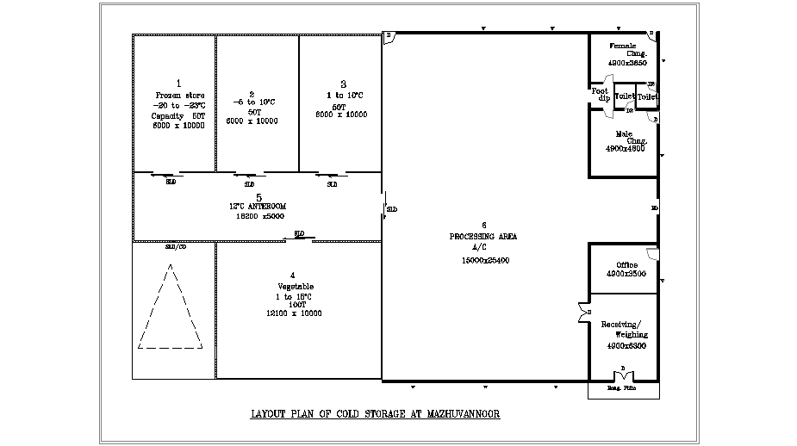

COLD STORAGE - MAZHUVANNOOR, ERNAKULAM

Sl.No | Description | Capacity | Room Dimension (in meters) |  |  | Temp.  range | Total connected load(KW) | Capacity of DG set
 |  |  | L | B | H
1 | Room No.1-Frozen Store | 50 T | 6.00 | 10.00 | 4.50 | -20 to -23 |  | 100 KVA
2 | Room No.2-Vegetable Room | 50 T | 6.00 | 10.00 | 4.50 | +10 to -5
3 | Room No.3 – Vegetable Room | 50 T | 6.00 | 10.00 | 4.50 | +10 to 1
4 | Room No.4  (for future expansion) | Approx: 100 MT | 12.10 | 10.00 | 4.50 | +15 to 1 | 62.33KW
5 | Room No.5-Common Ante Room |  | 18.20 | 5.00 | 4.50
6 | Processing Area |  | Room  15.20 | 25.40 | 4.20
 |  |  | Passage  5.00 | 4.60 | 4.20
7 | Receiving and weighing Room |  | 6.20 | 4.90 | 4.20
8 | Workers Change Room |  | Section I
 |  |  | 3.65 | 4.85 | 3.60
 |  |  | Section II
 |  |  | 4.80 | 4.85 | 3.60

2.4 Layout and Facilities of Cold Storage at Kalpetta

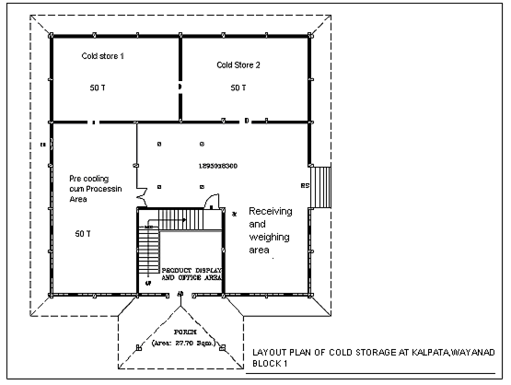

TECHNICAL DETAILS - COLD STORAGE - KALPETTA, WAYANAD

Sl.No | Description | Capacity | Room Dimension (in meters) |  |  | Temp.  range | Total connected load(KW) | Capacity of DG set
 |  |  | L | B | H
1 | Cold store 1 | 50 T | 9.30 | 6.10 | 3.20 | -20 to -23 | 14.60 | 63.5 KVA
2 | Cold store 2- | 50 T | 9.30 | 6.10 | 3.20 | +10 to -5 | 14.60
3 | Pre cooling & Processing Area | 50 T | 12.76 | 6.25 | 3.60 | +20 to +18 | 10.00
4 | Receiving & Weighing Area |  | 12.95  6.35 | 6.30  6.50 | 3.60  3.60
5 | Product Display Area& Office Area |  | 4.70 | 4.70 | 3.60

Layout of the Adjacent Building with Packing and Preprocessing Facilities at Kalpetta:-

Adjacent Building – Kalpetta, Wayanad

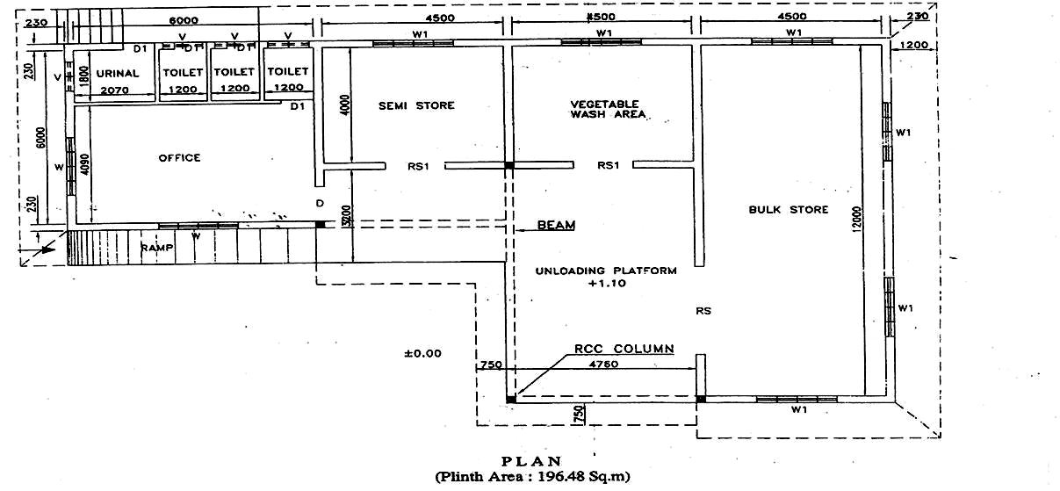

TECHNICAL DETAILS – ADJACENT BUILDING - KALPETTA, WAYANAD

Sl.  No | Description of additional facilities available | Room Dimension (in meters)
 |  | L | B | H
1 | Office | 4.09 | 6.00 | 3.60
2 | Semi Store/preprocessing area | 4.00 | 4.50 | 3.60
3 | Vegetable wash area | 4.00 | 4.50 | 3.60
4 | Bulk store | 12.00 | 4.50 | 3.60
5 | Unloading platform | 4.76 | 7.77 | 3.60
2.5 Primary Processing Center (PPC) as an additional project component

The plots in which Cold Storage are located, may be utilized for setting up additional project components to function as Primary Processing Center, which is attached to proposed KINFRA Mega Food Park at Palakkad. The additional project component may include,
- Dry warehouse for storage of raw materials with crates/crate handling systems
- Pack house with sorting and grading line for fruits and vegetables.
The objective of Primary Processing Centres is to carry out pre-processing of farm produce collected directly from farmers and dispatch it to either Centralized Processing Centre (CPC) (at Mega Food Park, Palakkad) for higher value addition activities or dispatch it to fresh retail markets or for exports.

2.6 Scope of facilities and services to be offered in the Cold Storages by the Operating Agency
2.6.1 | Operating, running and maintaining the cold storages for a period of 30 years.
2.6.2 | Maintenance/ rectification of the existing equipment, if required
2.6.3 | Maintenance/ rectification of the existing electrification system, if required
2.4.4 | Maintenance/ rectification of the building, if required
2.6.5 | Maintenance/ rectification of the existing firefighting system/other supporting systems, if required
2.6.6 | Providing pallets, crates and other material handling infrastructure required for cold storage operations
2.6.7 | Completing the overhauling and maintenance of cold storages and the cold storages should be ready for operation within four months from the date of handing over possession of the cold storage to the successful bidder.

  - Scope of facilities and services envisaged for the Pre-Processing Centers

    - Pre-processing of farm produce includes cleaning, grading, sorting, peeling and packing of various farm produces.

    - Receipt of raw materials for temporary storage and issue of the same subsequently either to the Mega Food Park or to the retail market or for exports.

    - The additional project component of the Pre-processing would be implemented at a later stage. The RFP for additional components (including financial terms for use of pre-processing center) would be issued when the facility will become ready for operation. The operations of the additional project components may be taken up (1) either by the selected Operating Agency, if selected through the RFP route or (2) by a new Operating Agency (called Sub-Operating Agency) selected through the RFP route, to whom Operating Agency will sublet the Pre-processing part of the facility based on mutually agreed terms (as per the RFP for additional components) between KINFRA, Operating Agency and Sub- Operating Agency.

3. directives TO BIDDERS

3.1 Acknowledgement of the RFP
3.1.1 | The interested parties shall download the Request For Proposal (RFP) document from KINFRA’s website on payment of Rs. 5000.00/- (Rupees Five Thousand only) towards the fee of RFP document (Rs.* 5000/ plus VAT @ 5%) and the same shall be paid through a Demand Draft drawn in favour of Managing Director , KINFRA and submitted along with RFP documents to KINFRA.
3.1.2 | The bidders must fill, duly sign and return to KINFRA by letter or telefax the “Acknowledgement of Request for Proposal and Notification of Intent to Bid” form, attached as Annexure A before the pre-bid meeting which is scheduled to the held on 23rd November 2015.

  - Pre-Bid Conference
    - In order to clarify and discuss the issues with respect to the PROJECT, a Pre-Bid Conference shall be held with the Bidders on 23rd November 2015 at 3.00 PM at KINFRA ANNEXE Office, Vellayambalam.
    - Attendance of the Bidders at the Pre-Bid Conference is mandatory. Bidders, who do not attend the Pre-Bid Conference, will be disqualified from the further procedures and KINFRA has the right to not respond to questions or inquiries from any such Bidders.
    - The Bidders should indicate whether or not they intend to attend the Pre-Bid Conference, and should fill, duly sign and return to KINFRA by letter or telefax, the “Attendance at Pre-Bid Conference” form, attached as Annexure B before the Pre-Bid Conference.

  - Validity of Bid
    - Each Bid shall indicate that it will remain valid for a period not less than 180 days from the due date of the submission of the Bid (Bid due date). KINFRA reserves the right to reject any bid, which does not meet this bid validity requirement.

3.4 Tentative Schedule for the Bidding Procedure

3.4.1 The tentative schedule of the Bidding procedure is as follows. The schedule is subjected to change at the discretion of KINFRA.
Sl. No. | ACTIVITY | DATE  (Tentative) | TIME  (Tentative)
1 | Pre-Bid Conference | 23rd November 2015 | 3.00 PM
2 | Last date of submission of Technical proposal /Business plan and Financial bid | 23rd December 2015 | 3.00 PM
3 | Opening of Technical proposal /Business plan | 23rd December 2015 | 4.00 PM
3 | Opening of Financial Bid | Will be intimated later

3.5 Bid Due Date
3.5.1 Business / Development Plan & Price Bid for each location should be submitted in two separate sealed envelopes, super scribed “Business Plan for the Operation and Maintenance of Cold Storages at KINFRA Park, -----------(Mazhuvannoor/ Kalpetta)” and “Price Bid for the Operation and Maintenance of the Cold Storages at KINFRA Park, --------- (Mazhuvannoor/ Kalpetta)” respectively which will then be enclosed in one single sealed envelope for each location, clearly super scribed “Business Plan & Price Bid for the Operation and Maintenance of Cold Storages at KINFRA Park, -----------(Mazhuvannoor/ Kalpetta)”, on or before 23rd December 2015 on the address provided in the RFP. Bids submitted by facsimile or telex will not be accepted.
3.5.2 The interested parties may download the RFP document from the website of KINFRA and make payment of Rs. 5000/- (Rupees Five Thousand only) towards the fee of RFP document (Rs. 5000/- +VAT @ 5%) through a Demand Draft drawn in favour of Managing Director, KINFRA, payable at Trivandrum and submit the same along with RFP proposal.

3.6 Earnest Money Deposit
3.6.1 The Bidder must submit an interest free Earnest Money Deposit (EMD) of Rs. 1,00,000 /- (Rupees One Lakh Only) by way of Demand Draft (DD) drawn in favour of Managing Director, KINFRA, payable at Trivandrum. The Bids not accompanied by EMD will be summarily rejected. The EMD must be submitted along with the bid, in a separate sealed envelope, super scribed “Earnest Money Deposit”.
    - The EMD of all unsuccessful Bidders will be returned within a period of thirty (30) days from the date of signing of the License Agreement with the successful Bidder. The EMD of any Bidder, whose Bid is rejected on account of being Non-Responsive or Non-Reasonable in accordance with the RFP, will be returned within a period of thirty (30) days from the date of intimating the rejection of bid by KINFRA to the Bidder.
    - EMD of the successful bidder will be adjusted against the first year lease rent on signing the lease deed within the stipulated time.

  - Format and Signing of Bids
    - Bidder shall prepare one (1) copy of each bid for submission, in addition to the original bids. The bids and their copy shall be typed or written in indelible ink. The bidder shall initial any corrections/ amendments made to the bid.

3.8 Changes to Submitted Bids
    - Any material change to a submitted Bid, must be received before the Bid due date. Material changes in the Bid will not be permitted after the bid due date.

3.9 Sealing and Marking of Bids
    - The Bidder should provide all the information as per this RFP. KINFRA would evaluate only the Bids in the required format. Business / Development Plan & Price Bid for each location should be submitted in two separate sealed envelopes, super scribed “Business/Development Plan for the Operation and Maintenance of Cold Storages, at KINFRA Park, ---------- (Mazhuvannoor/ Kalpetta)” and “Price Bid for the Operation and Maintenance of the Cold Storages at KINFRA Park, --------- (Mazhuvannoor/Kalpetta)” respectively which will then be enclosed in one single sealed envelope clearly super scribed “Business/Development Plan & Price Bid for the Operation and Maintenance of Cold Storages at KINFRA Park, ------------- (Mazhuvannoor/ Kalpetta)”.
    - The Bidder shall submit the Price Bid in the prescribed format as given in the Annexure C/D of this RFP. The Bidder shall quote a Lease Premium (in lump sum amount), higher than the upset price fixed by KINFRA. Any conditional Price Bid or Price Bid not in the format will be rejected.

3.9.3 The envelopes shall be addressed to:
ATTN. OF : THE MANAGING DIRECTOR
KINFRA
ADDRESS : KINFRA House, TC 31/2312,
Sasthamangalam,
Trivandrum – 695 010
Tel: 0471-2716585

3.9.4 KINFRA assumes no responsibility for the misplacement or premature opening of the Bids submitted. KINFRA will not be responsible for any postal delays or delay in transit for submitting the Bids.

3.10 Right to accept any Bid and to reject any or all Bids
3.10.1 Notwithstanding anything contained in this RFP, KINFRA reserves the right to accept or reject any Bid/Bids and to annul the bidding process and reject all Bids, at any time prior to the signing of the license agreement without incurring any liability to the rejected Bidder/Bidders or any obligation to inform the affected Bidder/Bidders of the grounds for rejection.

3.11 Successful Bidder
3.11.1 The successful Bidder shall be selected based on the maximum lease rent offered among the technically qualified bidder.
3.11.2 The Operation of Cold Storages will be awarded to the successful Bidder and would be intimated to come for signing of the Lease deed with KINFRA
  - Security Deposit
The successful bidder shall make an interest free security deposit equal to one year annual lease rent (minimum rate + quoted amount) at the time of execution of the lease deed either by demand draft or in the form of bank guarantee from a scheduled bank towards the due performance of the obligation of the Operator under the lease deed and for recovery of any damages caused to the building or its fittings.
Such security deposit will be refunded to the Operator on the expiry of the lease or otherwise on termination of the lease after adjusting any amount found due to KINFRA
  - Default and forfeiture of EMD
3.13.1 The EMD will be forfeited under the following circumstances:
- If the successful Bidder does not sign the Lease deed within ten (10) days of issuance of intimation, after furnishing the security deposit.
- If the Bidder withdraws his offer during the validity period as mentioned in Clause 3.3.1

3.14 Approval
3.14.1 The selection of the Successful Bidder (Operator) will be subject to the approval of the Board of Directors of KINFRA.
4. SELECTION PROCESS

  - Pre-Qualification Criteria

The technical bid would be evaluated on the basis of the following eligibility criteria and valid documents furnished by the bidder. The financial proposal of only pre-qualified bidders would be opened.
    - General

- The bidders must be Companies incorporated in India or registered partnerships in India or proprietary concerns.

    - Financial criteria

- A minimum annual service turnover of Rs. 50.00 lakhs in any of the preceding three financial years.
- A minimum net worth of Rs. 25.00 lakhs in any of the preceding three financial years. (Audited financial results for the year 2011-12, 2012-13 & 2013-14 and Chartered Accountant Certificate is to be provided)

    - Experience criteria
- Key technical/managerial person engaged by the applicant firm should have experience of over 5 years for round the clock operations in operating, running and maintaining the cold storages.

    - Financial bid evaluation criteria
The technically qualified bidders, who satisfies the eligibility criteria as above will be evaluated on the basis of the price bid. The price bid will have only one unconditional offer, i.e. the annual lease rental payable over and above the ‘specified minimum rate’ by the bidder. All other financial conditions will be fixed and no deviation will be allowed. They are as follows:
- Minimum Rate per month is fixed as (a) Rs 84,241.00 per month for Cold Storage at Mazhuvanoor and (b) Rs 20,352.00 per month; (Service Tax extra) and quotes below these amounts will be rejected respectively.
- Lease rent to be paid monthly in advance on the contract date
- Lease rent will be escalated every two year @ 12%.
- Lease deposit of one year lease to be deposited on signing the contract.
- Operation and maintenance contract will be for a period of thirty years, which can be terminated from the either side by 6 months notice.
- Service tax will be applicable for lease rent.
The bid will be selected on the basis of the highest lease rent bidder.
4.1.5 Bidding Process
The technical qualification documents will be evaluated to assess if the applicant satisfies the minimum eligibility criteria required to qualify to bid for operating and maintaining the Cold Storages.
The financial bids of the proposals received would be opened and evaluated of only those bidders who satisfy the above eligibility criteria.

  - Format of Bids
The technical proposal should be submitted with a covering letter as per Annexure E and should include all the required details in the format as given in Annexure F.

    - The technical proposal should contain
- The details of key technical/managerial persons proposed to be engaged by the applicant firm with experience of over 5 years for round the clock operations in operating, running and maintaining the cold storages. The details provided should also include the name, age, educational qualifications and experience key technical/ managerial persons. Copy of bio-data may be submitted.
- Business plan should indicate proposed cold storage capacity utilization, material/ stock identified for cold storage, the investment proposal, i.e. amount of proposed investments, period, and operational plan.
- Documents proving that the bidders must be companies incorporated in India or registered partnership in India.
- Documents proving net worth of the bidder

    - Financial bid shall be submitted in the format given as ANNEXURE C/D.

5. TERMS& CONDITIONS
  - The Cold Storages will be given to the Operating Agency in “as is where condition”. The rectification works of existing equipments, electrical, fire fighting system, all support systems and building shall be executed by the Operating Agency. No external additions, alterations, modifications to the existing building shall be made in any manner without the written consent of KINFRA and the Operating Agency shall maintain the building in good tenable condition. Any additional equipment desired by the Operating Agency shall be procured, installed and maintained at Operating Agency’s own cost with prior consent from KINFRA.
  - The Operating Agency should make use of Cold Storage facilities for their own use as well as a common facility center for others needing cold storage equipments. The Operating Agency should operate and maintain Cold Storage round the clock and all seven days of the week without interruption.
  - The lease rent should be paid in advance before 30 days of the due date every month. Service tax is applicable for lease rent.

  - All rates, taxes including service tax, building tax during the lease period and all assessments, charges, claims, consent fee levied by the Pollution Control Board, demands and outgoing shall be borne by the Operating Agency.
  - The Operating Agency shall maintain the building, Cold Storage equipment and supporting equipments, electrical installations etc handed over by KINFRA in good condition and shall compensate KINFRA for any damages to such properties with its replacement value.
  - The Operating Agency shall employ his own employees for running the Cold Storage and KINFRA will not be liable for any claim in respect of such employees.
  - There is no employer and employee relationship between KINFRA and the employees engaged by the Operating Agency, and employees engaged by the Operating Agency shall be his own employees for all statutory laws such as Minimum Wages, Gratuity Act, Payment of wages Act, Bonus Act, Workmen Compensation act, Employees Provident Fund Act, ESI Act, Shop and Commercial Establishment Act and all other labour laws whether central or State and the Operating Agency shall comply with all the requirements of such laws.
  - The employees engaged by the Operating Agency shall be courteous in their behavior towards the guests and employees of the KINFRA and if any complaints are received about their behavior, the Operating Agency shall take immediate step to remove such employees from the premises on a notice from KINFRA.
  - All employees engaged by the Operating Agency shall be given proper identification card with photo to identify them from other employees of other units functioning in the Park
  - The vehicles coming to the Cold Storage should be parked only at the allotted premises within the Cold Storage area and shall not cause any inconvenience or annoyance to other units and for the free movements of other vehicles with in the park
  - On the expiry of lease period or otherwise on termination of the lease the Operating Agency shall surrender vacant possession of the building together with its equipments, fixtures and fittings and also any future structures constructed by the Operating Agency except additional equipment exclusively acquired out of the funds of the Operating Agency’s, with due permission from KINFRA within three months from the date of termination of the agreement and the Operating Agency shall remove all the interior alterations, partitions and other fittings, erections made to the building at the cost of the Operating Agency, within the above three months, failing which KINFRA shall remove such alterations, partitions and other erections and the cost of such removal will be received from the Operating Agency or from the security deposit lying with KINFRA.
  - The Operating Agency shall not set up any title over the building and or on its equipments, fixtures and other fitting handed over to the Operating Agency adverse to the title of the owner and shall not be entitled to claim any compensation for any addition or modifications made on the building.
  - All sanctions, permissions, no objections, letters of intent, consent, licenses, clearance, approvals etc. shall be obtained by the Operating Agency at his cost and such documents shall be kept effective and in force during the tenure of the lease period
  - The building, equipments, furniture and fittings excluding additional equipments exclusively acquired out of the funds of the Operating Agency, shall be kept insured against fire, theft, burglary, tempest, rioting and other possible calamities and the insurance policy shall be taken in the joint names of KINFRA and the Operating Agency and the insurance policy shall be kept renewed and shall be in force at all times during the lease period and the insurance premium shall be borne by the Operating Agency. A copy of the insurance policy shall be furnished to KINFRA within 7 days of its renewal. The additional equipments exclusively acquired out of the funds of the Operating Agency may be kept insured by a separate insurance policy by the Operating Agency.
  - The products stored in the Cold Storage shall be preserved by correctly maintaining the required temperature. The Operating Agency shall indemnify KINFRA for all claim for damages or any action taken by any persons against KINFRA for any injury or losses caused or suffered by any person due to any act or omission on the part of the Operating Agency in providing quality services in the Cold Storage and for any claim for damages arising out of such action of the operating Agency and / or his employees
  - The Operating Agency shall maintain the Cold Storage and its premises in good sanitary condition and undertake annual maintenance of the building at his cost at regular intervals.
  - KINFRA shall have the right to inspect the premises and building at all reasonable time without notice to take note of the condition of the building, equipments, fittings and fixtures and it is the responsibility of the Operating Agency to repair or replace all damaged furniture and fittings at his own cost.
  - The Operating Agency shall not sublet, under let, lease, assign or transfer the operation of the Cold Storage to any other agency and shall not encumber the properties by way of pledge, hypothecation, mortgage, charge, lien, lease, leave and license or in any other manner without authorization from KINFRA.
  - The Operating Agency should cover his establishment under the Employees Provident Fund and Miscellaneous Provision Act, 1952 (Central Act XIX of 1952) and the Employees State Insurance Act, 1948 (Central Act of XXXIV of 1948).
  - KINFRA will not be vicariously liable for any act of the Operating Agency and Operating Agency shall alone be liable for violation of any law and the Operating Agency agrees to indemnify KINFRA from all claims.
  - The Operating Agency shall obtain power connection directly from KSEB. The operating Agency shall also pay the electricity charges to KSEB as per tariff fixed by KSEB from time to time. Transformer and generator will be provided by KINFRA in “as is where is condition.”
  - The operating Agency shall pay the water charges to KINFRA as per tariff fixed by KINFRA from time to time
  - The Operating Agency may at any time terminate the agreement before the expiry of the lease period for violation of the terms of the agreement by giving six months notice to KINFRA and in such event the Operating Agency shall not be entitled to get refund of the security deposit.
  - On the expiry of the lease, the Operating Agency shall hand over all articles, which were entrusted as per the schedule annexed in good condition to the satisfaction of KINFRA.
  - In case of any dispute between the parties only the Court in Thiruvananthapuram have jurisdiction to entertain any such dispute.

ANNEXURE A

ACKNOWLEDGEMENT OF THE REQUEST FOR PROPOSAL AND NOTIFICATION OF INTENT TO BID

The undersigned hereby acknowledges receipt of the RFP from Kerala Industrial Infrastructure Development Corporation and gives notice of its intent to submit the Bids. The undersigned confirms that the Applicant is in possession of the entire RFP.

Note: This form should be duly signed and returned to KINFRA by letter or tele-fax before the pre-bid meeting which is scheduled to be held on 23rd November 2015

The letter should be addressed to the attention of the Managing Director, KINFRA, in the address for correspondence given in the Bid.

..……………………………… ..………………………………
Name (Company) Signature

..……………………………… ..………………………………
Name of Signatory (Printed) Title of Signatory (Printed)

..……………………………… ..………………………………
Date of Receipt of Document Date of transmittal of this form

ANNEXURE B

ATTENDANCE AT THE PRE-BID CONFERENCE

The Pre-Bid Conference is scheduled on 23rd November 2015 at KINFRA ANNEXE Office, Vellayambalam, Trivandrum. The Conference will begin at 3.00 PM.

The undersigned hereby confirms that the Bidder will [ ] will not [ ] attend the Conference.

The number of representatives expected to attend the Pre-Bid Conference is [ ]. The name(s) of person(s) likely to attend/represent the Bidder is/are as follows:

1. ………………………………..

2. ………………………………..

3. ………………………………..

(Please note that all attendees should carry an authorisation by the Bidder).

The undersigned hereby acknowledges that he/she understands that if the Bidder does not attend the Pre-Bid Conference, KINFRA is not obligated to respond to inquiries from the Bidder after the date of the Pre-Bid Conference.

Note: This form should be duly signed and returned to KINFRA by letter or telefax before the Pre-Bid Conference to the address for correspondence given in the Bid.

..……………………………… ..………………………………
Name (Company) Signature

..……………………………… ..………………………………
Name of Signatory (Printed) Title of Signatory (Printed)

..………………………………
Date of transmittal of this form

ANNEXURE C

Price Bid
Operation and Maintenance of Cold Storage in KINFRA Small Industrial Park at Mazhuvannoor

I / We hereby offer to KINFRA, a Lease Rent for the operation and maintenance of the Cold Storage in KINFRA Small Industrial Park at Mazhuvannoor as per the following table.

Total fixed minimum upset price for Cold Storage at KSIP Mazhuvannoor |  | Lease rent offered
Amount in figures (Rs) | Amount in words  (Rs) | Amount in figures (Rs) | Amount in words  (Rs)
84,241.00 | Eighty Four Thousand Two Hundred and Forty One only

Lease rent will be escalated every two year @ 12%.

Service Tax will be extra

I / We hereby declare that all the terms & conditions stipulated by KINFRA with regard to this PROJECT have been gone through carefully and are acceptable to me /us. The maximum payment offered by me/us in lieu of the lease of the Cold Storage is furnished above. We are also willing to accept the instructions issued by the Managing Director, KINFRA, anytime with regard to the operation, running and maintenance of the Cold Storage.

Place: Signature

Date: Name & Address of authorized signatory

Note: The Annual Lease Rent offered should be higher than the Total Minimum Upset lease rent for the Cold Storage at KSIP Mazhuvannoor fixed by KINFRA.

ANNEXURE D

Price Bid
Operation and Maintenance of Cold Storage in KINFRA Small Industrial Park at Kalpetta
I / We hereby offer to KINFRA, a Lease rent for the operation and maintenance of the Cold Storage in KINFRA Small Industrial Park at Kalpetta as per the following table.

Total fixed minimum upset price for Cold Storage at KSIP Kalpetta |  | Lease rent offered
Amount in figures (Rs) | Amount in words  (Rs) | Amount in figures (Rs) | Amount in words  (Rs)
20,352.00 | Twenty Thousand Three Hundred and Fifty Two only

Lease rent will be escalated every two year @ 12%.

Service Tax will be extra

I / We hereby declare that all the terms & conditions stipulated by KINFRA with regard to this PROJECT have been gone through carefully and are acceptable to me /us. The maximum payment offered by me/us in lieu of the lease of the Cold Storage is furnished above. We are also willing to accept the instructions issued by the Managing Director, KINFRA, anytime with regard to the operation, running and maintenance of the Cold Storage.

Place: Signature

Date: Name & Address of authorized signatory

Note: The Annual Lease Rent offered should be higher than the Total Minimum Upset lease rent for the Cold Storage at KSIP Kalpetta fixed by KINFRA.

ANNEXURE E
Format of Letter by Applicant

To,
The Managing Director,

Kerala Industrial Infrastructure Development Corporation,

KINFRA House, TC 31/2312, Sasthamangalam,
Thiruvananthapuram- 695010

Sub: Request For Proposal for running and maintenance of Cold Storage –Technical proposal.
Dear Sir,

We, the undersigned Applicant have read and examined in detail the RFP Bid document for operation, running and maintenance of Cold Storages at KINFRA Small Industries Parks at Mazhuvannoor and Kalpetta.

We confirm having submitted all the details in support of qualifying criteria as required by you along with this Application and all other necessary documents. In case you require any further information in this regard, we agree to furnish the same.

We hereby declare that the Statements made in this proposal are true and accept that any misinterpretation contained in it may lead to our disqualification.

We hereby declare that we were never blacklisted by any Central/ State Government/PSU/Public Authority or Organization.

We understand that you are not bound to accept all or any RFP bid you receive.

Yours sincerely,

……………………………… ..……………………………….
Name (Company) Signature

..……………………………… ... ..…………………………
Name of Signatory (Printed) Title of Signatory (Printed)

..………………………………
Date of transmittal of this form
ANNEXURE F
Format of Applicants Profile

Name of the applicant
Address

Constitution (Company/ Firm/ Trust)
Details of EMD submitted
Details of a clear business plan with detailed plan for the running and maintenance of the Cold Storage.

Details of business plan which indicates the investment proposal, amount of investment and period of operational plan.

Details of minimum annual service turnover of 50 lakhs in any of the preceding three financial years.
Details of minimum net worth of 25 Lakhs in any of the preceding three financial years.
Details of audited financial results for the year 2011-12, 2012-13 and 2013-14
Details of supporting documents that the Key technical/managerial person engaged by the firm has experience of over 5 years for round the clock operations in operating, running and maintaining the cold storages
Details like name, age, educational qualifications and experience of key technical/ managerial persons.
Details of comfort letters regarding investment and operating funds
Contact Person (Name & Designation)
Telephone
Email
Address
Note: Additional data may be provided if required, in separate sheets.

