Invites Expression of Interest (EOI) for setting up of Global Ayurveda Village (GAV) at Thonnakkal, Trivandrum, Kerala

From Reputed Parties in the Ayurvedic sector experienced in Health & Wellness Service/manufactures/academicians for Joining the SPV as Anchor Partner

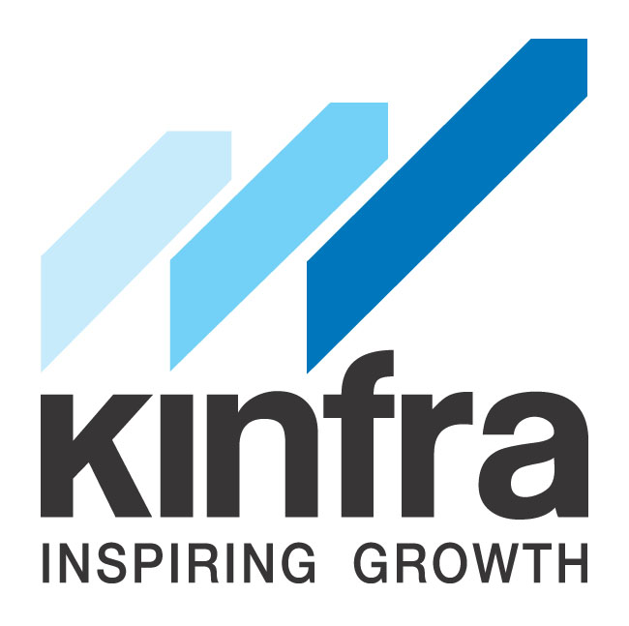

Issued on: 17.12.2015

KERALA INDUSTRIAL INFRASTRUCTURE DEVELOPMENT CORPORATION
(A Statutory Body of Government of Kerala)
KINFRA Corporate Head Office, KINFRA House, TC 31/2312, Sasthamangalam P.O,
Thiruvananthapuram, Kerala, India - 695 010
|Tel: 0471-2726585 | Fax: 0471-2724773 | Web: www.kinfra.org |
- Disclaimer

a. This EOI is not an agreement and is neither an offer nor invitation by Client (KINFRA) to the prospective applicant (Bidder) or any other person. The purpose of this EOI is to provide with information that may be useful for the prospective applicants and bidders are required to make their own inquiries and satisfy themselves regarding the completeness and reliability of the information and not to rely solely on the information in this document.
b. Neither KINFRA nor their employees, consultants, advisors or agencies make any representation or warranty as to the accuracy, adequacy, correctness, completeness or reliability of the EOI and any assessment, assumption, statement or information contained therein or deemed to form part of this EOI. Each prospective applicant should conduct its own investigations and analysis and check the accuracy, adequacy, correctness, completeness or reliability of the information in this EOI document and obtain independent advice from appropriate source before submission of the application against this EOI.
c. KINFRA may, in its absolute discretion but without being under any obligation to do so, update, amend or supplement the information, assessment or assumptions contained in this EOI.
d. Neither KINFRA nor their employees, consultants, advisors or agencies will have any liability to any prospective bidder or any other person under the law of contract, for any loss, expense or damage which may arise from or be incurred or suffered in connection with anything contained in this EOI document.
e. KINFRA reserves the right to reject any or all of the application submitted in response to this EOI document at any stage without assigning any reason whatsoever. KINFRA also reserves the right to hold, withdraw or cancel the process at any stage under intimation to the applicants who submit the application against this EOI.
f. KINFRA reserves the right to modify or amend or add to any or all of the provisions of this EOI document or cancel the present invitation and call for fresh invitations.
g. Neither KINFRA nor their employees, consultants, advisors or agencies will have any liability in case of non-receipt of any correspondence from them to the applicants due to postal delays.
h. The applicable laws for the purpose are the laws of INDIA. Courts of Kerala will have the jurisdiction concerning or arising out of this EOI document.

2. Definitions
- Application/Bid shall mean the response to this EOI with all documents as specified.
- Client shall mean KINFRA, its authorized agencies and assignees.
- Applicant(s)/Bidder(s) shall mean all Parties/ Companies/Firms/ who respond against this EOI.
- KINFRA shall mean Kerala Industrial Infrastructure Development Corporation, a statutory body formed by the Government of Kerala (GoK), represented by its Managing Director which expression unless it be repugnant to the context or meaning thereof, deemed to mean and include its successors and assignees.
- GAV shall mean “Global Ayurveda Village Project”
- LOA (Letter of Award) shall mean the letter issued by KINFRA to the successful
applicant inviting him to sign the MOU.
- Site shall mean the place where the location of the GAV for which the services as mentioned under the scope of work for the project are to be carried out.
- Bid Evaluation Committee (BEC) shall mean a team of Technical/Financial/Legal or any other expert constituted by KINFRA for evaluation of documents submitted by the applicants in response to the EOI.
- The Project means development of Global Ayurveda Village with all enabling facilities.

3. INTRODUCTION
Kerala Industrial Infrastructure Development Corporation (KINFRA) is a statutory body formed by the Government of Kerala in 1993, by an act of State Legislature for facilitating the development of industrial infrastructure in the State. KINFRA has played a pioneer role in developing industrial infrastructure in the State of Kerala.
KINFRA has a very successful track record in setting up 22 industrial parks across Kerala for facilitating development of the industry in the State.
KINFRA has taken the initiative of promoting the concept of ‘Theme Based Parks’ since its inception in 1993. After understanding the needs of a particular industry, KINFRA identifies common needs and accordingly provide common facilities to promote the concept of ‘shared infrastructure’ as a facilitating measure to attract investors of that particular industry. Examples of Theme Based Parks already commissioned by KINFRA include Industrial Parks for Garments, Entertainment, Exports based industry, Bio-technology, Food processing and SME industrial sector etc.
KINFRA also provides exclusive single window clearance facility for units in its Parks for obtaining regulatory licenses and clearances.
KINFRA is the nodal agency of GOK for setting up of the Global Ayurveda Village (GAV) at Trivandrum in Kerala for the development and promotion of Ayurveda Industry and to transform Kerala as the “World Capital of Ayurveda”.

4. PROJECT DETAILS
The GAV attempts to incorporate most modern scientific developments in diagnostic aspects of treatment with classical Ayurveda. The aim is to bench- mark the project with the Global Centers of traditional medicine and develop it as “Integrated Centre of Excellence in Ayurveda” to overcome the challenges of Ayurveda in the path of Global Recognition. The project aims to provide an enabling infrastructure, which will address to the current gaps in the growth of Ayurvedic medical system and enhance the opportunities with value added service and an integrated approach to modern science. Government of Kerala proposes to develop this project with a motive to Transform Kerala as The World Capital of Ayurveda as the “Integrated Centre of Excellence in Ayurveda”.
The project site at Chempakamangalam, Thonnakkal, Trivandrum admeasuring Ac. 7.48 is 32 KM from Airport and well connected by Road. The project will be developed and operated by a Special Purpose Vehicle (SPV) which will be registered as a Private Limited Company under Companies Act 2013. Each of these services in the facility would be provided in lieu of a service charge.
The ultimate goal for GAV is to develop an internationally renowned integrated Centre of Excellence in Ayurveda. GAV aims in becoming a prime destination for patients from all around the world seeking top-notch Ayurvedic diagnosis and treatment.

5. SALIENT FEATURES OF THE PROJECT:
The project will have two components.
1. Centre of Clinical excellence
- A 50 Bed Ayurveda Treatment Facility which shall be upgraded to 100 bedded (In patient & Out Patient) with NABH Accreditation incorporating all most modern amenities for diagnosis, treatment, rejuvenation, wellness by super speciality Ayurvedic management.
- A Centre equipped with latest diagnostic & surgical facility ( NABL Accreditation)
- Panchakarma Facility,
- Integration of Yoga , Meditation and Naturopathy with Ayurveda

- Knowledge Centre
- Tele Health Facility, Public Health Interventional
- Digital Library with self-sustainable model
- Standardisation /Documentation facility
- Human Resource Development Facility with Finishing School, Practical training programme, skill development program, Online training facility and international Academy
- Incubation Centre
- Ayurveda Food Court
- Cottages, Conference Hall
6. MODE OF IMPLEMENTATION
KINFRA proposes to set up the Global Ayurveda Village (GAV) “an Integrated Centre of Excellence in Ayurveda” at Chempakamangalam, Thonnakkal (32 KM from Trivandrum), in the state of Kerala.
- GAV is proposed to be developed with the participation of private partners as a PPP model. The proposed model envisages government involvement through KINFRA in providing land with compound wall, whereas the anchor partner would be responsible for providing other infrastructure, buildings, necessary equipment’s, consumables, technical and other manpower etc. for establishing, running and maintenance of the facilities.
- The Anchor partner shall be responsible for identifying the co-partners and their corresponding equity.
- The anchor partner shall be responsible for the entire operation and management of the centre.

The proposed period of completion of the project is 24 months from the date of formation of SPV (date of financial closure).
GAV will be implemented as a public- private partnership (PPP) model. As per the DPR the total cost of the project for site 1 is estimated to be 32.5 Cr approx. (including land cost), out of which 10 Cr is proposed to be availed as grant-in aid from AYUSH Department, Government of India. Balance amount of project cost will be funded by equity from KINFRA and anchor partners, Co-partners. KINFRA,’s equity will be in the form of land cost subject to minimum of 26% and maximum of 49% of the total equity. The anchor partner can take a maximum of 25% as equity. The anchor partner will be responsible for setting up operation and maintenance of the “Integrated Centre of Excellence in Ayurveda” constituting the Centre of Clinical Excellence and Knowledge Centre. The remaining equity shall be allotted to other private partners (co- partners) not less than 6 in numbers. These co-partners shall take a minimum of 1% of the total equity capital but not more than 20% out of the remaining 26 % - 49% of the equity. The remaining equity will be allotted on private placement basis as may decided by Anchor partner. The SPV will have a Board of Maximum 10 members (excluding chairman who will be from KINFRA) from KINFRA and Private Investors depending on the proportion of equity held by the partners. This Board will have overall control of the administration of GAV.
- The project is expected to run on a PPP mode.
- KINFRA will provide land with compound wall.
- All equipment’s and support infrastructure shall be provided by the anchor partner.
- Doctors required to run the hospital and rest of the manpower (Para Medicals, Nurses, Technicians, administrative and Support Staff etc) will also be provided by the anchor partner
- Day to day operational cost such as medicine cost, consumables/reagents costs etc for the project shall be borne by Anchor partner.
- The entire operation and maintenance of the GAV shall be managed by the anchor partner.

6.1. SPECIAL PURPOSE VEHICLE (SPV) & ITS ROLE:
The project will be developed and operated by a Special Purpose Vehicle (SPV) with equity participation from KINFRA, an Anchor Partner and Co- Partners from Private/Public sector/Individual. The Anchor partner shall be responsible for identifying the co-partners and their corresponding equity. SPV will be responsible for implementation and management of the GAV Project. Government of Kerala through its various representatives will hold a minimum of 26% and maximum of 49% of the Share of the SPV at any point of time and the balance 51% to 74% share will be offered to interested and eligible anchor parties. This EOI is for the selection of anchor partner and other equity partners of not less than 6 persons to form the SPV.
7. Eligibility of Applicants for Anchor Partner
The eligible applicant shall meet all the following conditions
- Experience in running an integrated Ayurvedic hospital with at least 5 doctors including modern medicine doctors
- Minimum 10 years of operational experience in Ayurveda hospital
- Experience in running a minimum 40 bedded Ayurveda hospital with modern amenities with lab, ECG, Physiotherapy, Yoga, and multi system experts with panchakarma theatres
- Annual turnover of minimum 1 crore in the preceding 3 years
- Preceding three years (2012-13 to 2014-15) audited annual financial statement showing profit in each year.
- Experience in running GMP certified Ayurveda drug manufacturing units.
- Experience in Ayurveda Health Tourism based holistic healing centre with green leaf certification

- EOI TO BE SUBMITTED IN THE FOLLOWING FORMAT:
Sl. No. | Description | Details
1 | Name of the Company/Institution
2 | Location of Corporate Office
3 | Main area of Business
4 | Details about the Drug manufacturing unit
5 | Turnover in the last consecutive 3 years
6 | Whether Interested in Joining the SPV as Anchor Partner with equity participation

- FOLLOWING DOCUMENTS TO BE SUBMITTED ALONG WITH THE EOI:
1) Brief Company Profile
2) Balance Sheet and Profit & Loss Statement for the Years 2012-13, 2013-14 and 2014-15.
3) Copy of latest Income Tax Return
4) Copy of latest Service Tax Return
5) PAN Card Copy
6) Self Certification stating that the Company or its Subsidiaries / Associates are not Debarred / Blacklisted by any Central / State Governments, Government Departments, Government Bodies or PSUs.
7) Any other detail which the Applicant Company feels relevant in this regard.
- TIME LINE:
Sl. No. | Activity | Date
1 | Release of EoI Notification | 17 Dec 2015
2 | Last date for receipt of Queries | 26 Dec 2015
3 | Pre EoI Meeting | 28 Dec 2015 @ 11:00 AM
4 | Submission of EoI | 1 Jan 2016 @ 03:00 PM
5 | Bid Opening | 1 Jan 2016 @ 4.00 Pm
Note: If any of the above mentioned dates happens to be a holiday, the activity scheduled for that day would be held on the next working date at the same time and venue

- ADDRESS FOR COMMUNICATION AND SUBMISSION OF EOI:
The Managing Director,
Kerala Industrial Infrastructure Development Corporation (KINFRA),
KINFRA House, 31/2312,
Sasthamangalam,
Trivandrum – 695010
Kerala, India

Telephone: - +91 471 2727281 / 2727282
Fax: : - +91 471 2727241
E mail : muralikinfra@gmail.com ; prkinfra@gmail.com,
www.kinfra.org

